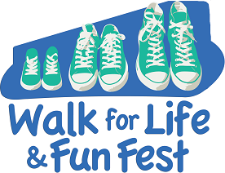
SAMPLE SPONSOR REQUEST LETTER

Dear Friend,

On December 9th, I am going to participate in the Annual Walk for Life to benefit Pregnancy Resource Center. PRC is a life-affirming ministry whose mission is prevent abortion and present eternal truth. They desire to see our community transformed into one where every baby is wanted. They compassionately serve women, men and families facing unplanned pregnancies, offering them a meaningful alternative to abortion. All of their services are provided free of charge – I am participating so they can continue serving all who walk through their doors!
Pregnancy Resource Center ministers in many ways:
- Through two PRC Clinics, they offer pregnancy tests, ultrasounds, the abortion pill reversal protocol, STD testing and treatment, and counseling while meeting spiritual and practical needs.
- Through their Education Center they offer support and practical assistance with material needs. Participants attend parenting classes, watch videos and complete homework, earning cribs, car seats and other baby necessities while developing healthy parenting skills.
- Through Restoration, they reach out to their clients and local churches to provide support to post-abortive men and women.

For more information, please visit their website at www.supportprc.org

I am writing to invite you to sponsor me. My goal is to raise [your goal amount]. Will you help? The pledge amount is not a per-mile pledge, but rather a one-time donation. Some sponsors give $100, some $25, others $10. Your gift is tax-deductible and any amount impacts lives!

You can send in your support with a check, cash, or donate to my personal online fundraising page here [your link].

Thank you for supporting me as I put my feet into action on December 9th.

Thank you,
[Your Name, phone # and email]

